Communication Management Plan Version 1.0

Group – 6

Team Members:
- Jeevan Bodigam
- Amulya Mallepalli
- Ajay kumar Reddy Arram
- Madhu Babu Konda
- Nagarushyanth Tummala

Date: 5/29/2021

Project Name: Location tracking shoe for kids

- Stakeholder communications requirements:
A project progress report is sent across all the stakeholders via an Email. Jeevan Bodigam is responsible for sending this email as per the communications summary listed below.

- Communications summary:

Stakeholders | Communications Name | Delivery Method/Format | Producer | Due/Frequency
Project steering committee | Weekly status report | Hard copy and short meeting | Madhu Babu Konda / Amulya Mallepalli | Monday,Wednesday 10 AM
Sponsor and champion | Monthly status report | Hard copy and short meeting | Ajay Kumar Reddy Arram | First Tuesday every week at 10 AM
Affected employees | Project announcement | Memo, e-mail, intranet site, and announcement at department meetings | Nagarushyanth Tummala | Due 5th June,2021
Project team | Weekly status report | Short meeting | Jeevan Bodigam | Thursday 10 AM

- Comments/Guidelines:

• If meetings are held on a statutory holiday, the meetings will take place the next business day.
• If the meeting is canceled due to problems, a detailed report on the contents to be discussed during the meeting must be shared with all stakeholders.
• Any delay in submitting a report must be notified at least 2 hours in advance.
• After each meeting, a report on what was discussed and the outcome of the meeting should be communicated to all stakeholders.

- Escalation procedures for resolving issues:

To report any development issues in the project, the below escalation matrix is used:

Madhu Babu Konda → Amulya Mallepalli → Ajay Kumar → Nagarushyanth → Jeevan

To report any issues related to scope, deadlines, etc. The escalation matrix to be followed is:
Team → Jeevan → Stakeholders

- Revision procedures for this document:

In case there are any changes to this document, the steps mentioned should be followed in order:
- Team makes necessary changes to the document with a new version number.
- Jeevan reviews the document and sends it to the stakeholders for signoff.
- After receiving all the signoff’s, they are documented and stored for a future reference.
- The updated document is published to all the stakeholders over an email communication by Jeevan.

Flowchart for the revision for the project:

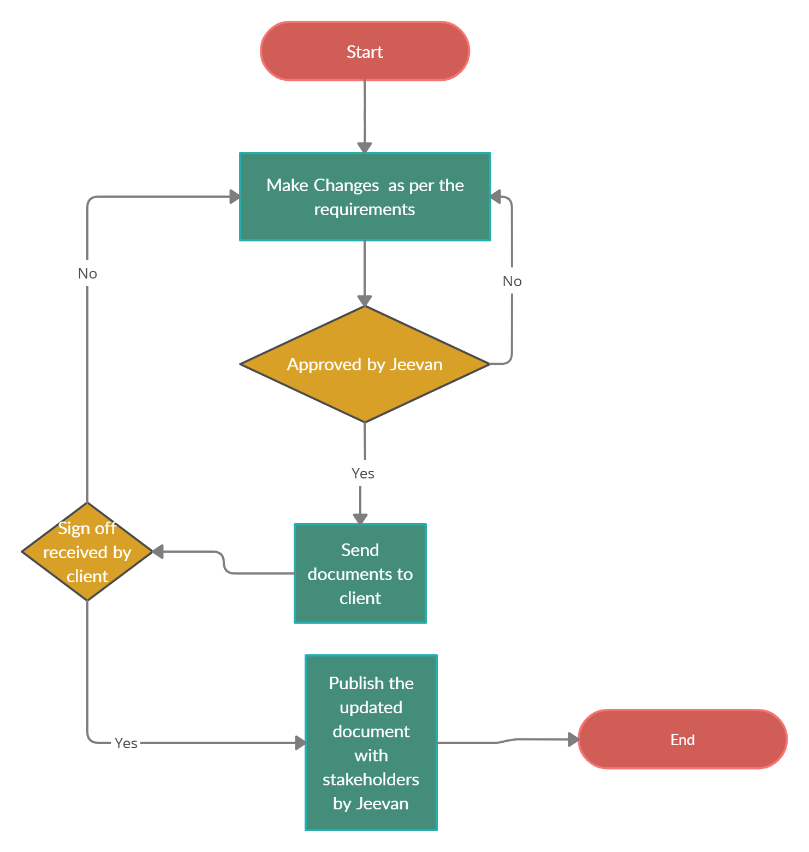

- Glossary of common terminology:

Champion:
A project champion is the person in the project organization who is responsible for ensuring that everyone involved is involved and behind the ultimate success of the project.

Deadline:
The goal date indicates when you want to complete a task.

Escalation:
Escalation is the process of bringing in higher levels of leadership or project management to resolve an issue.

Flow Chart:
A type of diagram that represents a process or workflow.

Project progress report:
A document that explains in detail the path taken to complete a project.

Scope:
The features and functionality of a product, or the scope of work, required to complete a project.

Sponsor:
A project sponsor is the person or group that owns the project.

Project Steering committee:
A project steering committee can be part of a larger project governance structure, responsible for managing the team's progress towards meeting project goals and timelines.

